Ýmir Þórleifsson

HW 1

# 3.2.1

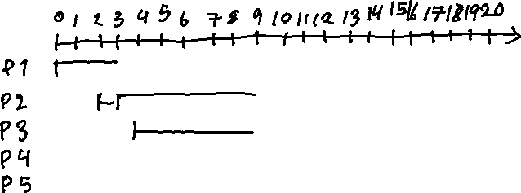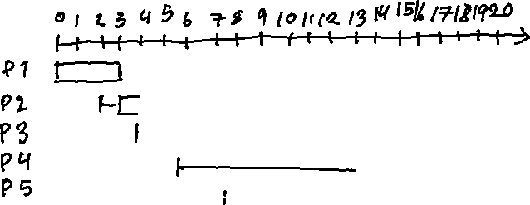

b)

FIFO ((0 + 3) + (1 + 6) + (5 + 4) + (7 + 5) + (10 + 2)) / 5 **8.6**

SJF ((0 + 3) + (1 + 6) + (7 + 4) + (9 + 5) + (1 + 2)) / 5 **7.6**

SRT ((0 + 3) + (7 + 6) + (0 + 4) + (9 + 5) + (0 + 2)) / 5 **7.2**

# 3.2.2

We get a p and q every 4 time units and both processes can finish in that time so we only focus on the first 4 time units. FIFO and SJF will behave the same in this problem.

FIFO & SJF ((0 + 3) + (2 + 1)) / 2 **3**

SRT ((1 + 3) + (0 + 1)) / 2 **2.5**

# 3.2.3

CPU burst sequence: 7, 5, 6, 15, 15, 15

Using formula:

1. α = 0.8

**7**

**5.4**

**5.88**

1**3.18**

**14.78**

1. α = 0.5

**7**

**6**

**6**

**10.5**

**12.75**

# 3.3.1

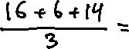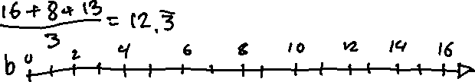

# 3.3.2



# 3.3.3

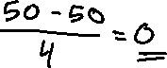

# 3.3.4

1. 0%. No time is wasted on context switching.
2. Approaches 0%.
3. Approaches 100%.
4. If time quantum is double that of the overhead.

# 3.3.5



# 3.4.1



# 3.5.1

